THE NEW ALSEA WATERSHED STUDY
George G. Ice, Cody Hale, Stephen Schoenholtz³, Jeff Light, Sherri Johnson, Terry Bousquet², and John D. Stednick
Abstract: The original Alsea Watershed Study assessed the effects of timber harvesting on water, aquatic habitat, and salmonid resources using a paired-watershed approach. The New Alsea Watershed Study provides an opportunity to evaluate water resource and salmonid resource responses to current forest practices compared to undisturbed conditions. It also allows a comparison to the original study results that included an extreme manipulation in the 1960s. Flynn Creek was an undisturbed control watershed in the original study and remains an undisturbed Natural Research Area under the USDA Forest Service. Deer Creek was partially cut and demonstrated the effectiveness of streamside management zones in the original study. Needle Branch was completely clearcut with subsequent slash burning, with no streamside vegetative buffers. Needle Branch experienced some of the most dramatic water quality impacts for temperature and dissolved oxygen ever observed in response to forest management. Increases in discharge, sediment, and nutrients were also measured, although these changes were more subtle. The water quality impacts observed for Needle Branch, especially temperature, are sometimes erroneously cited as the inevitable consequence of clearcutting in the Pacific Northwest. The regenerated forest in the Needle Branch watershed is again ready for commercial harvest. The proposed timber harvesting plan in Needle Branch involves two harvesting units and will provide an opportunity to assess cumulative effects on water resources. This new study, using paired watersheds, synoptic surveys of water quality, and biological monitoring, will test how effective current forest practices are in maintaining water quality.
WATER RESOURCE PROBLEM
Oregon was the first state in the nation to pass a forest practices act (1971) that provided for protection of water quality and fish habitat. In some cases, these forest practice rules must weigh environmental against economic benefits. This may be especially significant where landowners must forego timber harvesting to provide buffers around streams. Small, non-fish-bearing streams can represent a majority of the length of stream networks, so management near them can be especially contentious. The forests of the Oregon Coast Range are some of the most productive in the world and are commercially important to the timber industry of Oregon.
The Oregon Department of Forestry (ODF) and the Oregon Department of Environmental Quality (ODEQ) recently conducted a sufficiency analysis of the Oregon Forest Practices Act (OFPA) rules to determine whether the rules provided sufficient protection to watersheds and water quality (ODF and ODEQ 2002). Unfortunately, there were no watershed studies in Oregon on the impacts of contemporary forest practices on water quality and aquatic resources. Scientists at Oregon State University are using the Hinkle Creek Watershed Study in southwest Oregon to provide the first watershed test of contemporary forest practices. [The Hinkle Creek watersheds are located in the foothills of the Oregon Cascades, not in the Coast Range.]
ALSEA WATERSHED STUDY
The Alsea Watershed Study (AWS) began in 1957 as a cooperative effort between Oregon State University and federal and state agencies to address the effects of timber harvesting on the stream environment (Harris 1977). Results of the study were used to develop Best Management Practices (BMPs) for timber harvesting in the temperate coniferous forest (NCASI 1991; OSU 1999). The original study, as well as contemporary studies, illuminated key processes governing the hydrology of the temperate coniferous forests of the Pacific Northwest and changes in hydrologic processes following timber harvest and other forest management practices (Ice et al. 2004).
During the original Alsea Watershed Study (AWS), three small watersheds in the Coast Range near Salado, Oregon, were monitored from fall 1958 through 1973. Flynn Creek (500 acres) served as the control. Deer Creek (750 acres) was patchcut and burned, with uncut forest left along the main stream channel. Needle Branch (175 acres) was nearly completely clearcut (a small portion of the upper watershed was harvested in the 1950s) and slash burned without any stream protection (Figure 1). Such extensive clearcutting and lack of stream protection are no longer permitted under Oregon's Forest Practices Act, in large part because of the lessons learned from the Alsea Watershed Study. The AWS provided numerous lessons about water yields and peak flows, sediment loads, nutrient concentrations, temperature responses, dissolved oxygen impacts, and fisheries responses (Moring and Lantz 1975).
NEW ALSEA WATERSHED STUDY
After completion of the original study, Dr. John D. Stednick from Colorado State University re-instrumented the original gaging stations at Flynn Creek, Needle Branch, and Deer Creek. Streamflow monitoring has been ongoing since 1989, and some water quality sampling has also been conducted. A synthesis of the previous work on water and salmonid resources is nearly complete (Stednick and Hall in prep.). Stednick’s was designed to look at long-term watershed recovery patterns for the region. The study now being installed will measure the scale of improvements in water resource protection afforded by current forest practices rules.
We know from some interim monitoring that dissolved oxygen concentrations and water temperatures have returned to pre-harvest levels for Needle Branch. Further, we know that although there appears to have been an increase in nitrate-nitrogen concentrations for Needle Branch since harvesting, the nitrate-nitrogen concentrations are still higher in the control watershed (Flynn Creek) than in either of the watersheds that were harvested. The forest in the Needle Branch watershed has regenerated and is ready for commercial harvest. This paired-watershed study will test for progress in water resource protection over the last forty-plus years. Re-entry into Needle Branch by the landowner, Plum Creek Timber Company (PCTC), provides an opportunity to assess the effectiveness of today’s timber harvesting BMPs.
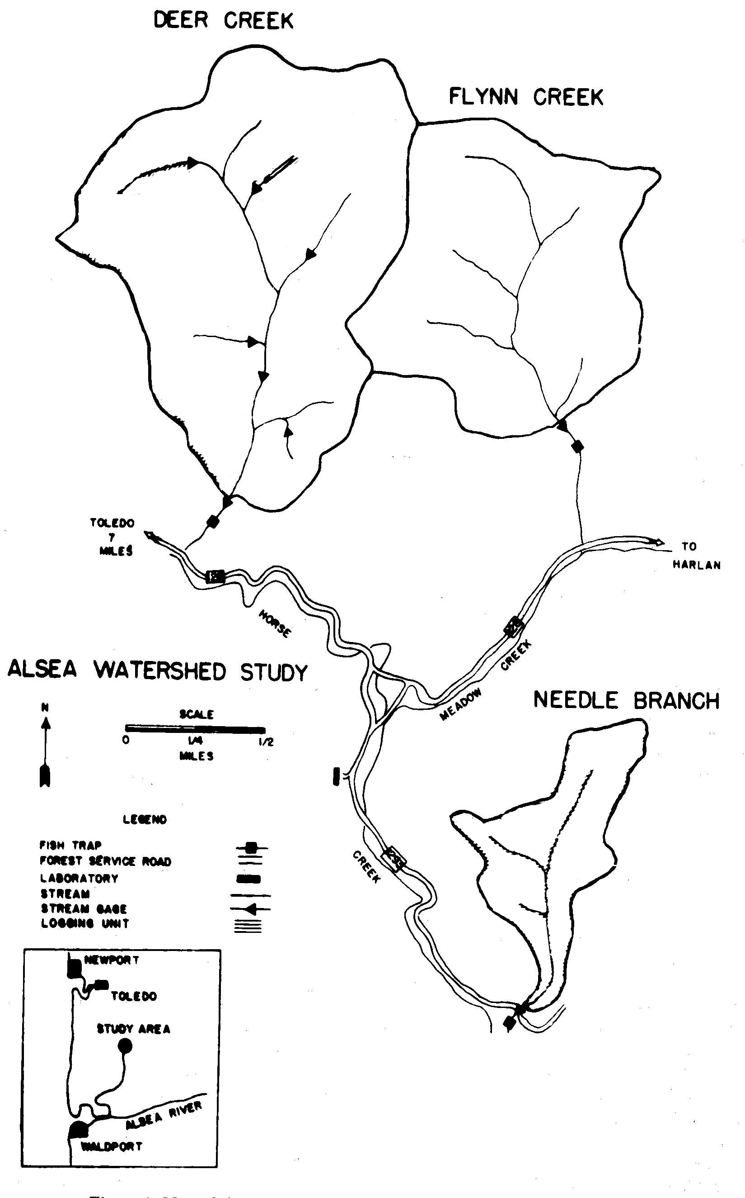
Figure 1. Alsea Watershed Study with dark green showing portions of the basins harvested in the original study and light green indicating timber harvests in 1979, 1988, and 1989.
PCTC manages approximately the upper two-thirds of the watershed and has committed to harvesting to meet the research needs of this study. The harvest will involve two units of about 88 acres each (Figure 2). Harvests are planned four years apart. Differences between the original study are mandated by current forest practice rules (clearcut size limits and green-up requirements between harvests).
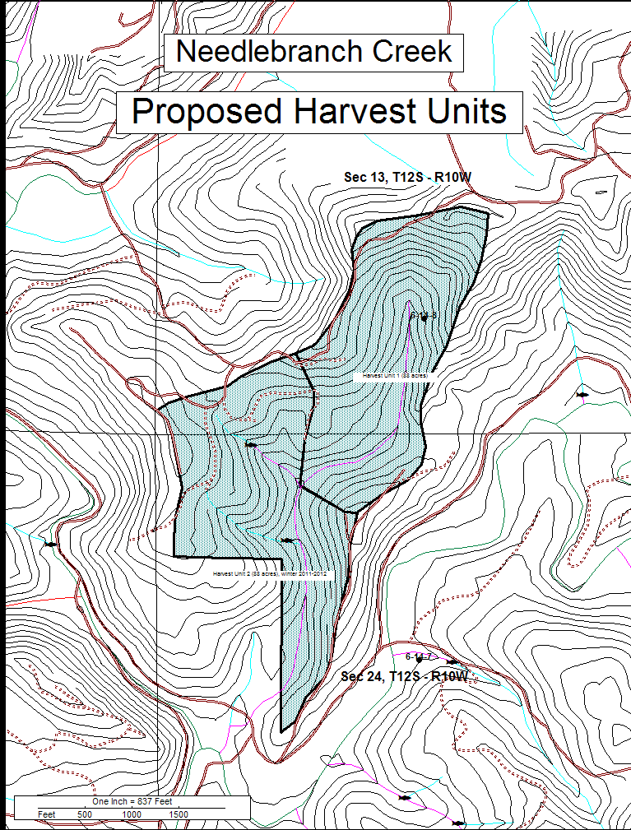
Figure 2. Proposed harvest units for Needle Branch.
Study Objectives
Study objectives include:
1. Measure streamflow at the original gaging station in Flynn Creek (control) and in Needle Branch immediately below the headwater harvest unit and at the main gaging station.
2. Measure water quality parameters of temperature, sediment, and nutrients over time and relate them to state and national water quality standards.
3. Assess BMP efficiency by comparison of water resource responses to management activities and water quality standards to measured responses from the undisturbed Flynn Creek.
4. Provide a synoptic view of water quality responses to complement the station-based monitoring.
5. Provide biological monitoring to assess macroinvertebrate community and fish responses to current forest management practices.
Methodologies used in this study will be similar to those used in the original study, but will also incorporate contemporary methods such as turbidity-activated pump samplers. The original USGS gaging stations and weirs are being used and a new gaging site will be built in the headwaters of Needle Branch below unit 1. A draft Study Design, Quality Assurance Plan has been prepared and a Data Management Plan is in development and will be posted on an Alsea Watershed website. Biological monitoring will be conducted at the watershed outlets, as well as in upper Needle Branch to measure the effects of harvesting near non-fish-bearing stream reaches where riparian management areas are narrower. The harvest in the upper reaches of Needle Branch and the staggered harvests will allow us to look at transport of impacts downstream and cumulative effects. Synoptic, basin-wide monitoring will further identify both natural and human-caused variations in water quality.
The effects of timber harvesting on fish populations and aquatic communities is an important issue that the forestry community continues to address. Cutthroat trout in the clearcut watershed (Needle Branch) showed an immediate and persistent drop in the older age classes. We believe that removal of wood debris from the Needle Branch channel was a significant factor in cutthroat trout declines because it eliminated important pool habitat in this very small stream. The fish monitoring component of the study will use census methods for fish in selected reaches to determine fish numbers. Passive Integrated Transponder (PIT) tags will be used to monitor the growth of individual fish in these streams. At the conclusion of the harvesting study there are plans to restore woody debris loads in Needle Branch.
The role of riparian forests on food for fish is another area of interest (Wilzbach et al. 2005). Sampling of benthic and emerging macroinvertebrates will be used to evaluate effects of forest harvest on streams. Taxa and their abundances will be collected twice a year in spring (May) and summer (end of July) for the two years before harvest and then compared with post-harvest conditions. Collections in Needle Branch will be obtained in headwater reaches scheduled to be harvested with and without buffers, and near the gaging stations. To account for between-year climatic variability, community composition and abundances from a stream of similar size in an unharvested basin (Flynn Creek and a sub-basin of Deer Creek) will also be collected. In addition to the standard quantitative collections obtained with Surber Samplers, kicknet samples will be collected for qualitative community composition evaluations using the River InVertebrate Prediction And Classification System (RIVPAC). This approach uses presence or absence of key taxa compared to an existing ODEQ database of macroinvertebrate composition from a range of impacted to pristine stream sites. These samples will be collected in the field by personnel from Oregon State University and analyzed and evaluated by Oregon Department of Environmental Quality.
CONCLUSIONS
The Alsea Watershed provides a unique opportunity to measure the scale of hydrologic, water quality, and aquatic organism responses to contemporary forest practices under the Oregon Forest Practices Act, and to compare these responses to the impacts of unrestrained harvesting without regard for stream protection. The New Alsea Watershed Study is a key measure of how far we have come in protecting water resources on commercially managed forests.
References
Harris, D.D. 1977. Hydrologic changes after logging in two small Oregon coastal watersheds. USGS Water Supply Paper 2037. United States Geological Survey.
Ice, G.G., P.W. Adams, R.L. Beschta, H.A. Froehlich, and G.W. Brown. 2004. Forest management to meet water quality objectives: Watershed studies and assessment tools in the Pacific Northwest. 239-261 in A Century of Forest and Wildland Watershed Lessons. Ice, G.G. and J.D. Stednick [Eds.]. Bethesda, MD: Society of American Foresters.
Moring, J.R. and R.L. Lantz. 1975. The Alsea Watershed Study: Effects of logging on the aquatic resources of three headwater streams of the Alsea River, Oregon. Fisheries Report 9 (in three parts). Corvallis, OR: Oregon Department of Fish and Wildlife.
National Council for Air and Stream Improvement, Inc. (NCASI). 1991. The New Alsea Watershed Study. Technical Bulletin No. 602. Research Triangle Park, NC: National Council for Air and Stream Improvement, Inc.
Oregon Department of Forestry (ODF) and Oregon Department of Environmental Quality (ODEQ). 2002. Sufficiency analysis: A statewide evaluation of FPA effectiveness in protecting water quality. Available at: http://egov.oregon.gov/ODF/PRIVATE_FORESTS/docs/fp/AllSAv1031.pdf.
Oregon State University College of Forestry (OSU). 1999. Water: It covers a lot of territory-water related research is looking at large landscapes over long periods. Focus on Forestry 12(1):4-12.
Stednick, J.D. and J. Hall. (in preparation). The New Alsea Watershed Study. New York: Springer Verlag.
Wilzbach, M.A., B.C. Harvey, J.L. White, and R.J. Nakamoto. 2005. Effects of riparian canopy opening and salmon carcass addition on the abundance and growth of resident salmonids. Canadian Journal of Fisheries and Aquatic Sciences 62:58-67.

Proceeding of the 2005 Society of American Foresters National Convention, Fort Worth, TX.
NCASI; PO Box 458; Corvallis, OR 97339; Phone: 541-752-8801; Fax: 541-752-8806
Forest Engineering Department, Oregon State University, Corvallis, OR; Phone: 541-737-4952
Plum Creek Timber, Company Toledo, OR; Phone: 541-336-6227
Pacific Northwest Research Station, USDA Forest Service, Corvallis, OR; Phone: 541-758-7777
College of Natural Resources, Colorado State University, Fort Collins, CO; Phone: 970-491-7248

